AMRITA VISHWA VIDYAPEETHAM, BENGALURU

Research Volunteering Work Completion Report
Name : Nalagala Suala Kavya
Roll Number : BL.EN.U4CSE23032
Hours of work completed : 8 hrs

Notes:
- The students shall work for a project related to Machine learning
- The students shall understand the problem statement and ideas / thought process for solution development
- Students shall submit a report of the work done duly signed by the guide / supervisor
- No of hours spent for the volunteering work should be clearly mentioned as that would be the criteria for awarding marks
- Each 1.5 hours of work translates to 1 mark subject to a cap of 5 marks
- Max marks allocated for this activity is 5 (~8 hours of work)

Problem Statement

This project's purpose is to preprocess and clean scanned images with Malayalam script to improve their quality for reliable text recognition and analysis. The dataset initially used for this project contained 8 images from the mentor, each containing approximately 10 lines of printed or handwritten Malayalam text. All of the lines were manually segmented from each image, which produced 80-line images for further processing. The segmented images were cleaned by removing unwanted backgrounds, margins, and noise and improving contrast and visibility within each line image

Work completed
I completed the process of cleaning and preprocessing eight images of Malayalam text, in order to make them ready to be read by OCR. Each image was meticulously cropped line by line, and the backgrounds deemed unnecessary were removed through noise reduction and contrast enhancement, which helped to increase line clarity. Through this, I experienced not only practical approaches on how to preprocess the image, but also the significance of data quality and a greater understanding of the script structure of Malayalam. My work will help the accuracy of OCR, aid in downstream processing, and contributes to the digital preservation of Malayalam manuscripts.
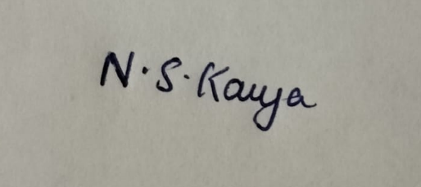
Signature of Student Signature of Faculty Member / Scholar
Name: Nalagala Suala Kavya Name: Remya Sivan
Date: 30/9/2025 Date:

